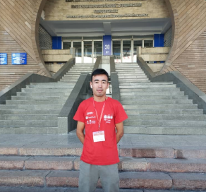 | Sapar Kutbidinov  Java Developer  Date of Birth: 17.05.2000  Сity: Andijan  Telephone: 0990551692  Email: ksapar517@gmail.com  linkedin: https://www.linkedin.com/in/sapar-kutbidinov
Education | Kyrgyz-Turkish Manas University Computer Engineering  September 2019 - June 2024
SkillS | Java, C++, Postman, Swagger, MVC, Git, Github, REST API, Html, Css , Javascript  Frameworks: Spring Boot, Bootstrap etc  Databases: PostgreSQL, MySQL  Competitive Programming: ICPC(.......), ACPC(.............) Hackathon (.............)
Projects | https://github.com/ksapar517
Languages | - Kyrgyz – Native  - Russian - Intermediate  - English -Intermediate  - German -Pre-intermediate
ADDITIONAL | - Secondary Education Electrician Engine  - Took second place at the Mathematical Olympiad in Andijan 2016  - Took Third place at the Republican Mathematical Olympiad in Andijan2019

